Social Media Sentiment Analysis

In this project we have a data about different social media platforms like Instagram, Twitter etc
So, in our dataset we have data like No of likes, No of comments, No of Shares, User follow count, Post type (image, video, text) etc.
Here is the look of our dataset
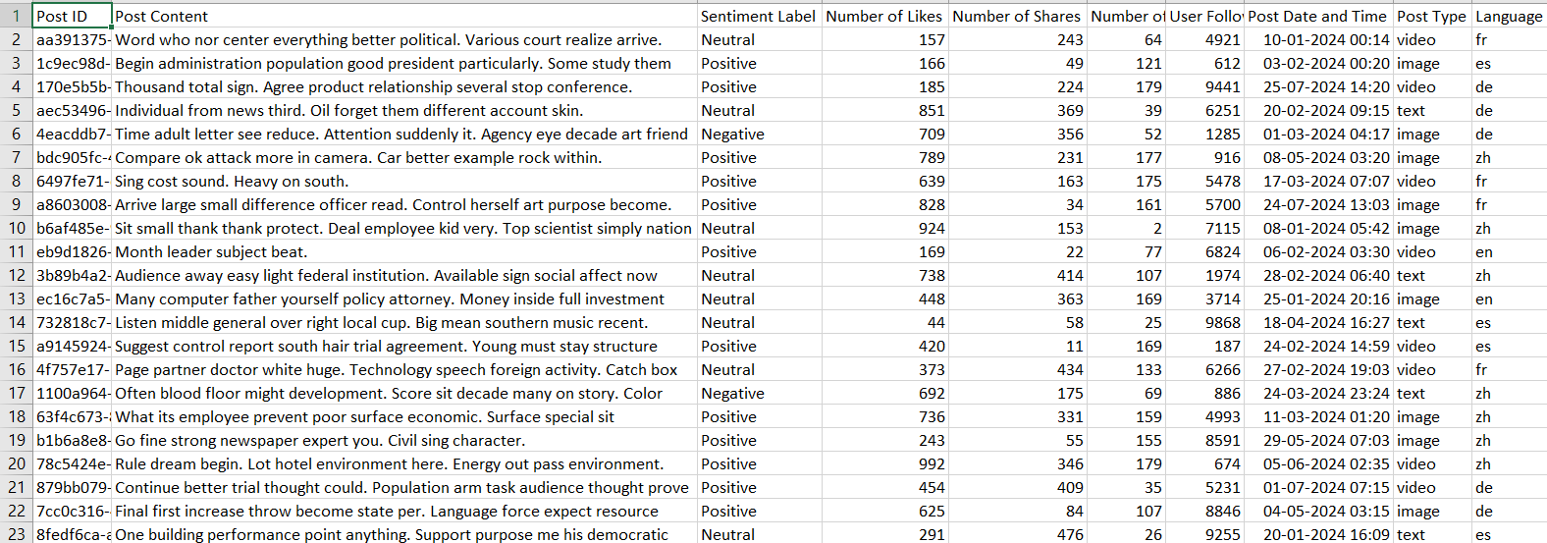
Our goal is to analyse this dataset and produce some insights by using some machine learning algorithms like linear regression, logistic regression.
There is a chance that we encounter the methods and libraries that we didn’t used until now. No worries we will learn and go.
So, Let’s get started…. Shall we
Be it any project first we have to import the dataset into the RStudio. To do that we have read.csv()
And if you don’t want to give path we can choose the path of the dataset everytime using file.choose().

SocialMediaData <- read.csv(file.choose())

So, After successfully importing the dataset what we should do everytime. We have to check for null values.
To do that we have is.na() method to say whether the entity is null or not. And to remove the null values we have na.omit().

sum(is.na(SocialMediaData))
SocialMediaData <- na.omit(SocialMediaData)

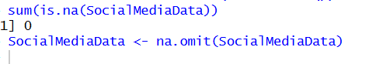
So now all ready with the dataset we have to preview the dataset and analyse the summary of the dataset.
head(SocialMediaData)
str(SocialMediaData)
summary(SocialMediaData)

head() is used to return the first 5-10 entries of the dataset.
Str() is used to analyse the column datatypes and other things.
Summary() is used for advanced analysis like mean, mode, min, max, 1st Quadrant, 3rd Quadrant etc.
For some technical issue we can’t give you the output of these. Because you will know while you execute them.
Now its time for some charts. Yes!! Its time for Exploratory Data Analysis.
EDA Exploratory Data Analysis

1.Sentiment Distribution Chart

In this we are trying to analyse the sentiment distribution of our dataset based on column Sentiment Label.
This Sentiment Label contains the data of reaction of the post like Positive, Negative, Neutral.
Now, we are trying to draw a chart on how many posts are Positive and how many are Negative. It is hard to count them because the dataset is huge.
We use a method called table() which counts the unique value in the column.
Then we try to draw a bar chart for the data.

Count_Table <-table(SocialMediaData$Sentiment.Label)
barplot(
Count_Table,
col = "steelblue",
border = "black",
main = "Sentiment Distribution Chart",
xlab = "Sentiment",
ylab = "Number of Posts"
)
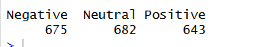
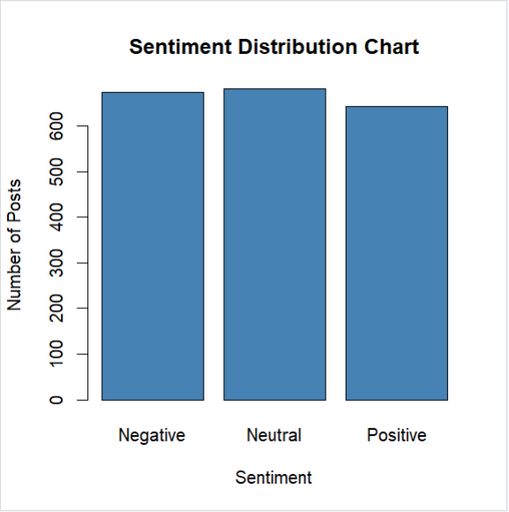

We all know the contents in the barplot(). I don’t waste time by explain that. You will know after seeing the output. If no remove the word from your desktop. You are unworthy for this notes.

2.Likes vs Sentiment

In this we tried to plot the Average Likes for positive, negative, neutral sentiment posts.
To do this we first have to divide data based on Sentiment and sum their likes and do an average then create a data frame for average likes and try to plot the dataset as a bar chart.

Total_Positive_Post_Count <- sum(SocialMediaData$Sentiment.Label == "Positive")
Total_Negative_Post_Count <- sum(SocialMediaData$Sentiment.Label == "Negative")
Total_Neutral_Post_Count <- sum(SocialMediaData$Sentiment.Label == "Neutral")

Total_Positive_Likes_Count <- sum(SocialMediaData$Number.of.Likes[SocialMediaData$Sentiment.Label=="Positive"])
Total_Negative_Likes_Count <- sum(SocialMediaData$Number.of.Likes[SocialMediaData$Sentiment.Label=="Negative"])
Total_Neutral_Likes_Count <- sum(SocialMediaData$Number.of.Likes[SocialMediaData$Sentiment.Label=="Neutral"])

Average_Positive_Likes <- Total_Positive_Likes_Count / Total_Positive_Post_Count
Average_Negative_Likes <- Total_Negative_Likes_Count / Total_Negative_Post_Count
Average_Neutral_Likes <- Total_Neutral_Likes_Count / Total_Neutral_Post_Count

Average_Likes_Sentiment <- data.frame(
Sentiment = c("Positive","Negative","Neutral"),
Average_Likes = c(Average_Positive_Likes,Average_Negative_Likes,Average_Neutral_Likes)
)
head(Average_Likes_Sentiment)
#2.1 Bar Plot
barplot(
height = Average_Likes_Sentiment $Average_Likes,
names.arg = Average_Likes_Sentiment $Sentiment,
col = "coral",
border = 'black',
xlab = "Sentiment",
ylab = "Average Likes",
main = "Average Likes per Sentiment"
)

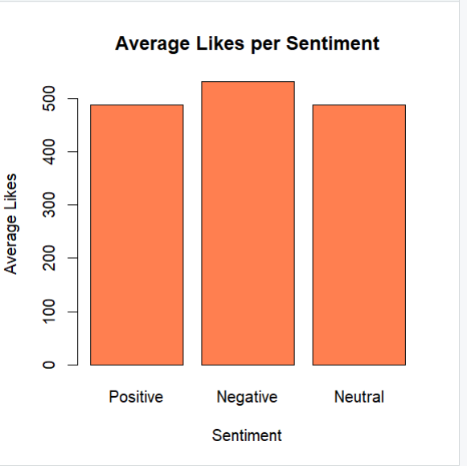
First, we calculated the number of Sentiment based posts in the dataset to make use of the data in calculating the average.
Then we calculated the number of likes for the Sentiment based posts and then we calculated the Average likes for Sentiment based posts.
Then we created a data frame for the average data then plotted it using barplot().

3. Most Liked Posts (Top 10 Post IDs)

To do this we can sort the data set based on likes on the posts. Then we take the head of the dataset.
So, to sort the dataset we use arrange(). Arrange() has two parameters they are as follow
1.DataSet ( obviously..)
2.Column that should be sorted based on desc() / asec()
Here we need top most liked post so we use desc()
Note: arrange() method is available in dplyr library. Make sure to import the library.

Sorted_by_likes <- arrange(SocialMediaData,desc(Number.of.Likes))
head(Sorted_by_likes,10)

4.Engagement Comparison (Likes, Shares, Comments)

This means through which engagement feature users are more interacting with the post in social media.
To do this we first have to calculate the total number of likes, shares, comments and try to plot the dataset.

Engagement_score <- data.frame(
Total_Likes = sum(SocialMediaData$Number.of.Likes),
Total_Shares = sum(SocialMediaData$Number.of.Shares),
Total_Comments = sum(SocialMediaData$Number.of.Comments)
)
engagement_values <- c(
Engagement_score$Total_Likes,
Engagement_score$Total_Shares,
Engagement_score$Total_Comments
)

engagement_names <- c("Likes", "Shares", "Comments")

barplot(
height = engagement_values,
names.arg = engagement_names,
col = c("darkred", "steelblue", "darkgreen"),
border = "black",
ylab = "Total Engagement",
main = "Engagement Comparison (Likes, Shares, Comments)"
)
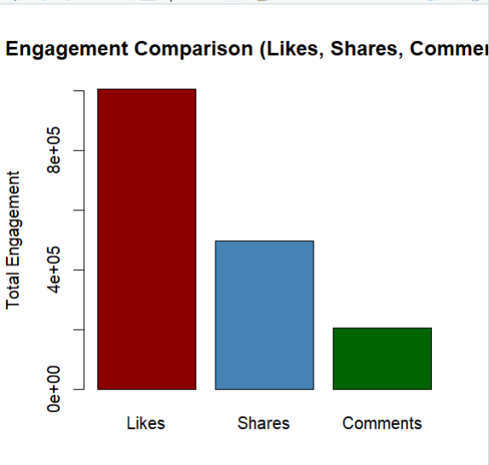
Through this we can confirm that users are interacting with likes than other two interacting feature.

5.Post Type vs Likes

In this we are trying to which post type(image, text, video) has more likes than the other.
To do this we first have to calculate the number of likes of the posts based on the post type.
Then try to plot the dataset using barplot().

Image_post_data <- sum(SocialMediaData$Number.of.Likes[SocialMediaData$Post.Type == 'image'])
Text_post_data <- sum(SocialMediaData$Number.of.Likes[SocialMediaData$Post.Type == 'text'])
Video_post_data <- sum(SocialMediaData$Number.of.Likes[SocialMediaData$Post.Type == 'video'])

Post_based_on_likes <- c(
Image_post_data,
Text_post_data,
Video_post_data
)
Post_like_names <- c("Image_Posts","Text_Posts","Video_Posts")
barplot(
height = Post_based_on_likes,
names.arg = Post_like_names,
col = c("steelblue","darkorange","green"),
border = "black",
ylab = "Likes Based on Post Types",
main = "Post Type vs Likes"
)
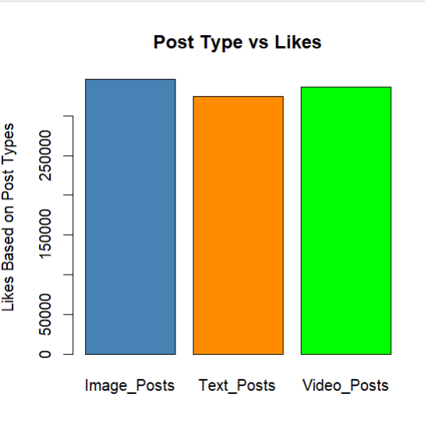
5.Followers vs Likes chart

In this we are trying to plot a chart that show the relation between the likes and the followers count for a post and admin.
For example, if 10 followers a post got only 2 likes. (simple example)
ggplot(
SocialMediaData,
aes(x = User.Follower.Count, y = Number.of.Likes)
) +
geom_point(color = "steelblue") +
geom_smooth(method = "lm", se = FALSE, color = "red") +
labs(
x = "Follower Count",
y = "Likes on Post",
title = "Followers vs Likes Relationship"
) +
theme_minimal()

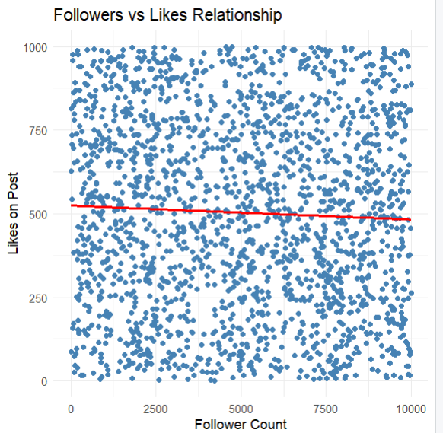
In this code geom_smooth() will draw a line between the dots using machine algorithm called logistic regression (lm). This is also called a trend line.

7. Language-wise Engagement

In this we try to plot the Language wise user engagement.
In this data set there are 5 languages English, German, Spanish, French, Chinese.
So, we are trying to plot total likes for a particular language.
Language_table <- table(SocialMediaData$Language)
Total_de_post_Likes <- sum(SocialMediaData$Number.of.Likes[SocialMediaData$Language == "de"])
Total_en_post_Likes <- sum(SocialMediaData$Number.of.Likes[SocialMediaData$Language == "en"])
Total_es_post_Likes <- sum(SocialMediaData$Number.of.Likes[SocialMediaData$Language == "es"])
Total_fr_post_Likes <- sum(SocialMediaData$Number.of.Likes[SocialMediaData$Language == "fr"])
Total_zh_post_Likes <- sum(SocialMediaData$Number.of.Likes[SocialMediaData$Language == "zh"])

Language_based_data <- c(
German_likes = Total_de_post_Likes,
English_likes = Total_en_post_Likes,
Spanish_likes = Total_es_post_Likes,
French_likes = Total_fr_post_Likes,
Chinese_likes = Total_zh_post_Likes
)
languages_cols = c("German","English","Spanish","French","Chinese")
barplot(
Language_based_data,
names.arg = languages_cols,
col = c("skyblue","green","orange","steelblue","pink"),
border = "black",
xlab = "Languages",
ylab = "Total likes",
main = "Language-wise Engagement"
)
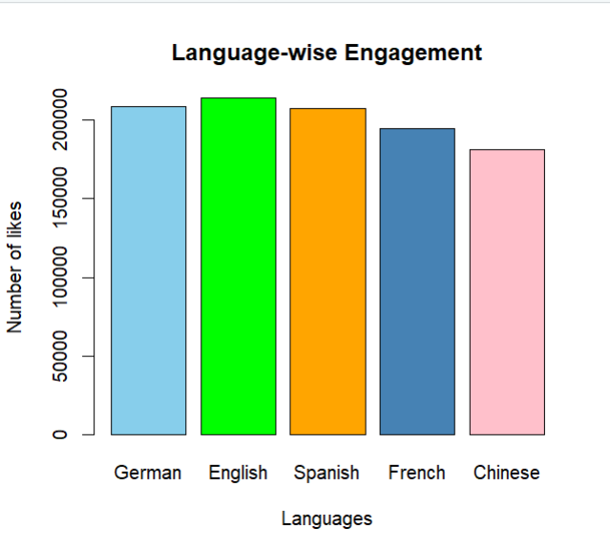
There is an easy and short way to do it using dplyr().

Language_based_data_short <- tapply(
SocialMediaData$Number.of.Likes,
SocialMediaData$Language,
sum
)

barplot(
Language_based_data,
col = "skyblue",
border = "black",
xlab = "Language",
ylab = "Total Likes",
main = "Language-wise Engagement"
)
tapply() splits the data and groups the data and applies the aggregated function on the data.
In tapply() we have give the order of the inputs very carefully first input is the values and second input is to on which basis data should be grouping and the third one is the function.
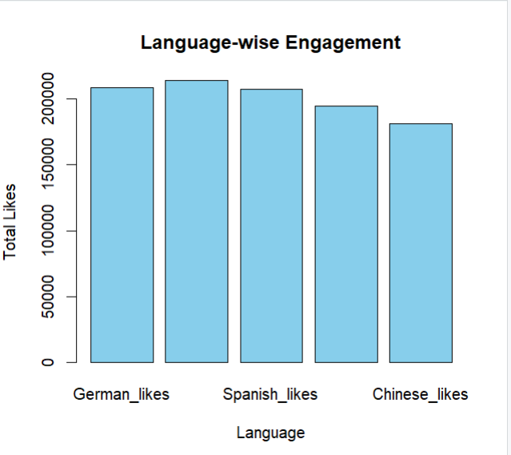

8. Followers Based Likes

In this we are trying to plot data as if the followers counts effect the engagement (Likes).
To do this we split the data into 3 levels
- Low Followers (<1000)
- Medium Follower (>=1000 and <5000)
- High Followers (>5000)
After splitting the data set we try to plot with bar plot.

Low_Followers <- sum(SocialMediaData$Number.of.Likes[
SocialMediaData$User.Follower.Count < 1000
])

Medium_Followers <- sum(SocialMediaData$Number.of.Likes[
SocialMediaData$User.Follower.Count >= 1000 &
SocialMediaData$User.Follower.Count < 5000
])

High_Followers <- sum(SocialMediaData$Number.of.Likes[
SocialMediaData$User.Follower.Count >= 5000
])

Followers_Based_likes <- c(
Low_Followers_users = Low_Followers,
Medium_Followers_Users = Medium_Followers,
High_Followers_Users = High_Followers
)
Followers_cols = c("LowFollowers","MediumFollowers","HighFollowers")

barplot(
Followers_Based_likes,
names.arg = Followers_cols,
col = c("steelblue","darkorange","green"),
border = "black",
ylab = "Total Likes",
main = "Likes Based on Followers"
)
legend(
"topleft",
legend = Followers_cols,
col = c("steelblue","darkorange","green"),
pch = 15
)

There is nothing new except the legend part. Legend is used to add the axis part to the graph.
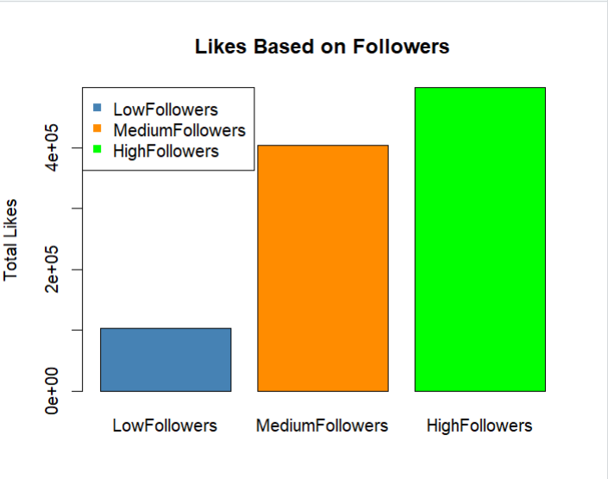
In the result we clearly seen that followers count is effecting the total likes.
9. Text Preprocessing

In this we are trying to analyse the text data in the dataset. In the dataset we have text data as Post Content.
First, we convert all of the data into lower case. (easy to analyse)
Then, we removing special characters and numbers form the data.
Then, we remove the unwanted text like the, that, this etc.
At last, we are splitting the data and converting them into numeric data using TF (Term Frequency), IDF (Inverse Document Frequency).
Now, we are using corpus for text analysis.
Corpus is a collection of documents used for text analysis in NLP and ML algorithms.
We are converting the Tokenized data into corpus because ML algorithms don’t directly analyse the raw text.

#Text Pre-processing
#1. Converting into Lower Case
SocialMediaData$Clean_Post_Content <- tolower(SocialMediaData$Post.Content)

#2. Removing numbers and Special Characters
SocialMediaData$Clean_Post_Content <- gsub("[^a-z ]","",SocialMediaData$Clean_Post_Content)

#3. Removing Unused words
stops_words <- c("the","is","am","are","and","this","that")
SocialMediaData$Clean_Post_Content <- gsub(paste(stops_words,collapse = "|"),"",SocialMediaData$Clean_Post_Content)

#4. Tokenization
SocialMediaData$Clean_Post_Content <- strsplit(SocialMediaData$Clean_Post_Content , " ")
head(SocialMediaData$Clean_Post_Content)

#TF-IDF
#TF (Term Frequency)
#IDF (Inverse Document Frequency)

corpus <- VCorpus(VectorSource(SocialMediaData$Clean_Post_Content))

tfidf_df <- DocumentTermMatrix(
corpus,
control = list(
weighting = weightTfIdf
)
)

dim(tfidf_df)
gsub() is used to remove the unwanted data. It’s like replacing the unwanted text with space.
strsplit() is used to split the data into tokens.
VCorpus() Converts the tokenized data into corpus.
VectorSource() will tell the RStudio that the input data is a Vector.
DocumentTermMatrix() converts the documents into matrix of words.
- Rows → Documents (social media posts)
- Columns → Terms (words)
- Cells → Weight / importance of a word in a document
TF → word importance in one post
IDF → word rarity across all posts
TF × IDF → final weight
dim() is used to know the dimension of the data set.

10. Logistic Regression
This is one the supervised learning algorithm in Machine Learning. It is used when the output is categorical type like YES/NO, SPAM/NOT SPAM.
In R programming to apply logistic regression we have a method called glm() which stands for logistic model. Our idea is to use this glm() for predicting the data of Sentiment Label (‘Positive’, ‘Neutral’, ‘Negative’)
But unfortunately, glm() method only takes binomial type of data i.e column with two unique data.
Here we have 2 options either remove one the Sentiment Label and use glm() or use multinom() for multinomial regression.
So, we used a new method called multinom() which is used for applying the logistic regression for multinomial columns.

SocialMediaData$Sentiment.Label <- as.factor(SocialMediaData$Sentiment.Label)

multiclass_logistic_model <- multinom(
Sentiment.Label ~ Number.of.Likes + Number.of.Shares +
Number.of.Comments + User.Follower.Count,
data = SocialMediaData
)

summary(multiclass_logistic_model)

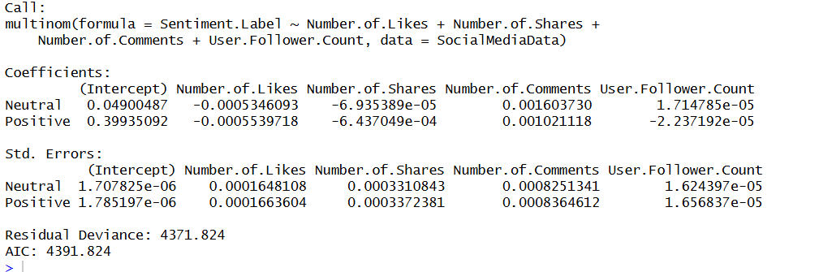

We have analysed the data using logistic regression now we to predict the data using the predict() method.
We have bunch of data so we need to use small amount of data from the predicted data.
predicted_probs <- predict(multiclass_logistic_model,type = "probs")

predicted_probs_dataframe <- as.data.frame(predicted_probs)

predicted_probs_dataframe$Post_ID
->1:nrow(predicted_probs_dataframe)
prob_df_sample <- predicted_probs_dataframe[1:20, ]

plot_ly(prob_df_sample, x = ~Post_ID, y = ~Positive, type = "bar", name = "Positive") %>%
add_trace(y = ~Neutral, name = "Neutral") %>%
add_trace(y = ~Negative, name = "Negative") %>%
layout(
barmode = "stack",
title = "Predicted Sentiment Probabilities per Post",
xaxis = list(title = "Post"),
yaxis = list(title = "Probability")
)
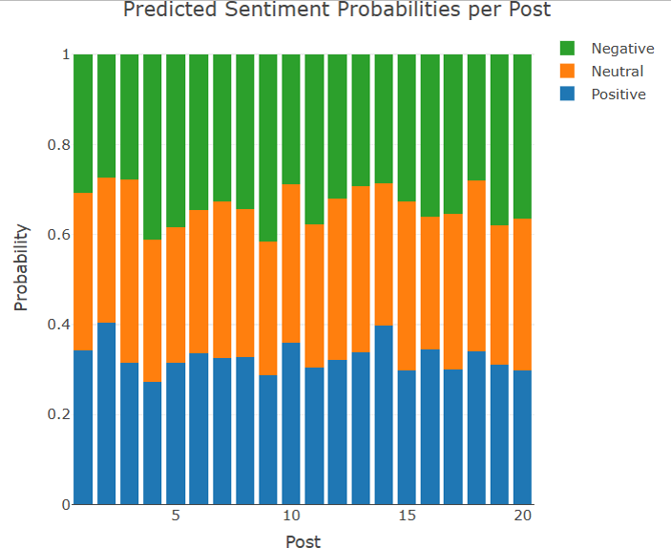
Now, we are trying to predict the Sentimental Label based on the words that are in the Post Content using Naïve Bayes Machine Learning model.
So, to use the Naïve Bayes we have a library called ‘e1071’. This method takes only data frame as the input. We need to convert the tfidf data into matrix then to data frame.
Then we split the data into train data and test data in the ration 7:1. Then we use the Naïve Bayes method to analyse the data. After we got the analysed data we can use the predict() to predict the future values.
Lastly, we create a confusion matrix to visualize the data. To visualize the data we are using plot_ly().

tfidf_matrix <- as.matrix(tfidf_df)

naive_bayes_data <- data.frame(
tfidf_matrix,
Sentiment.Label = SocialMediaData$Sentiment.Label
)
set.seed(18)

split <- sample.split(naive_bayes_data$Sentiment.Label, SplitRatio = 0.7)
test_data <- naive_bayes_data[split == FALSE, ]
train_data <- naive_bayes_data[split == TRUE, ]

naive_bayes_model <- naiveBayes(Sentiment.Label ~. ,data = train_data)
summary(naive_bayes_model)

naive_bayes_prediction <- predict(naive_bayes_model, newdata = test_data)
summary(naive_bayes_prediction)

#Confusion Matrix
conf_mat <- table(
Predicted = naive_bayes_prediction,
Actual = test_data$Sentiment.Label
)

summary(conf_mat)

#Visualize the Naive Bayes Data
confusion_matrix_data <- as.data.frame(conf_mat)

plot_ly(
data = confusion_matrix_data,
x = ~Actual,
y = ~Predicted,
z = ~Freq,
type = "heatmap",
colors = colorRamp(c("skyblue", "blue"))

) %>%
layout(
title = "Naive Bayes Confusion Matrix",
xaxis = list(title = "Actual Sentiment"),
yaxis = list(title = "Predicted Sentiment")
)

